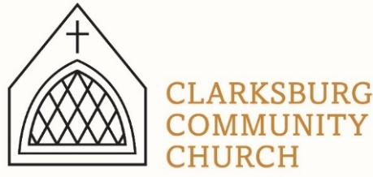
Non-Profit
Bulk Mailing
Clarksburg, CA
95612
Permit #1
Third Class
Chimes
PO Box 36 Clarksburg, CA 95612
52981 Netherlands Road
Summer 2021

“for a tree is recognized by its fruit.” -Matthew 12:33

Clarksburg Community Church
Things to know:

Upcoming Events
- Sunday worship at 10am on the lawn for July and August.
- Sunday, July 18, presentation of the Denomination Review Committee and Church Council recommendation for denominational affiliation.
- Wednesday, July 28, 6:30-8:30 pm- Question and answer forum in the sanctuary about the Church Council denomination recommendation.
- Sunday, August 15 following the worship service, church member meeting to vote on Church Council denomination recommendations.
- Wednesday, August 11, school begins in Clarksburg.
- Wednesday, September 1 -Youth Choir begins! Cherub (grades K-4) 6:00-6:40 pm, Junior (grades 5 and up) 6:45-7:30
New Playground at CCC
The new playground has been installed as part of an Eagle Scout project by Steven Faiello. Special thanks to Bo Dahlberg for coordinating and to Jeff Merwin for providing materials. We are happy to partner with our local Eagle Scouts and community members to accomplish projects in Clarksburg.
Youth Leader Update
Amanda Aragon will be greatly missed as she moves on to a full-time ministry position in Lodi. She has been the Youth Leader at Clarksburg Community Church for the last three years. We are grateful for her time and ministry here.

Contacting Clarksburg Community Church
The church office is open Monday and Thursday from 9am-1pm or by appointment.
Office Phone: 916-744-1422 or email information@clarksburgcc.org
Pastor Sandy Adams: pastorsandy@clarksburgcc.org
Office or children’s ministry, Tiffani Taylor: tiffani.taylor@clarksburgcc.org

Mission Updates
Clarksburg Community Church is proud to be supporting a couple of our own young women as they begin new ministry assignments this year.
Sally Clark will be in a full-time fellowship with EMI. EMI is a non-profit Christian development organization made up of architects, engineers, surveyors, and construction managers. They use their skills to serve people worldwide through the design of hospitals, schools, water systems, and many other facilities. If you would like to support Sally, please go to https://emiworld.org/sally-anne
Emma Winkler will be joining the Athletes in Action team at UOP in a part time position working to bring Christ to athletes and students on her college campus. Athletes in Action is part of Cru. To support Emma, please go to https://give.cru.org/1113136

Flowers for Worship
Thank you to all those who have donated flowers for the Sunday worship service: Dick Marshall, Christine Heringer, Gene Naugle, Claudean Thomas, Tom and Nell Wallace, and Charlyn Connor. We appreciate the beauty that flowers add to our sanctuary!
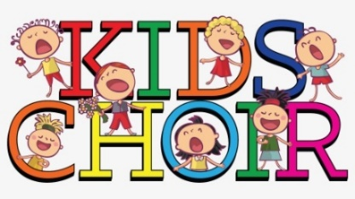
Youth Choir
Youth choir begins September 1! We offer two youth choirs. The Cherubs choir includes kinders through 4th graders. We learn the basics of music, rhythm, harmony and the joy of praising the Lord with song. There are lots of wiggles and movement while we sing and play. Junior choir is 5th grade and up. Junior choir dives further into music theory, rhythm, harmony and some musical theater. Both choirs will sing in the worship service on Sunday every four to six weeks. Youth choir is free and open to any interested students. Tiffani Taylor will be directing the youth choir again this year.
Cherubs practice -Wednesday from 6:00-6:40pm
Juniors practice- Wednesday from 6:45-7:30pm

In Memoriam
- Renee Holmes (Bennett), a former Clarksburg resident and member of Clarksburg Community Church, passed away peacefully last August – she was 97 years old. Please join the family in celebrating her life on August 28, 2021 at her beloved Echo Lake CA cabin, Please RSVP to Barbara Holmes Smith @ (916)821-3898 for details.
- Mary Ann Pylman passed away at her home in Clarksburg on July 5, following a long illness. She was 86 years old.
“Chiming In w/ Pastor Sandy”

In case you don’t know, 2021 is the 95th anniversary of Clarksburg Community Church (CCC) and for 53 of those years, we have been affiliated with the United Church of Christ (UCC). When we joined the UCC, it was a good fit for who our church was at that time. However, times change and so do denominations and local churches. Over the years, the question of whether or not CCC should remain in the UCC has been discussed. In 2020, the Church Council decided to formally investigate this question by forming the Denomination Review Committee.

The members of this committee comprised of Council members Bob Bartron, Don Clark, Jeff Merwin, Steve Heringer, Amanda Aragon, Tiffani Taylor and two church members, David Hunn and Raquel Rapp. I served as the committee’s chairperson. The committee was tasked with considering three possibilities: remain a member of the UCC, become an independent church or join another denomination. On May 25th, after five months of researching and discussing several options, the committee recommend to the Church Council that we end our affiliation with the UCC and apply for membership to the Evangelical Covenant Church.

The Evangelical Covenant Church is a biblically based denomination with around 900 churches globally and 154 in California. While “evangelical” has modern, political connotations it actually is an old, theological word simply describing a Gospel-centered perspective. While many other denominations were considered, the Committee believed the Evangelical Covenant Church was the best fit for our church. This past June 22nd, the Church Council unanimously approved the Committee’s recommendation be presented to the congregation for consideration and final vote. Below is an explanation of the next steps in this process:

Following the service on Sunday, July 18th a proposal and presentation from the Church Council will be shared about our current and future denominational affiliations. Wednesday, July 28th from 6:30-8:30 an open question and answer forum will take place in the sanctuary. Finally, the church membership will vote on the proposal by secret ballot on Sunday, August 15th.

This is obviously an important matter for our church to consider, so please pray that God’s will be done, and we will be unified as a church body. At any time during this process, please contact me or other members of the Church Council with your questions.

-Pastor Sandy

