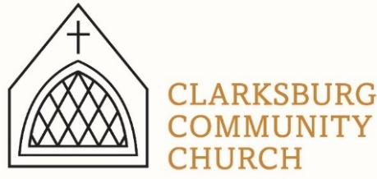
Non-Profit
Bulk Mailing
Clarksburg, CA
95612
Permit #1
Third Class
Chimes
PO Box 36 Clarksburg, CA 95612
52981 Netherlands Road
Summer 2022

Outdoor Worship Service
Sunday, July 3rd 10:00 a.m.
Clarksburg Community Church
Things to Know:
Announcements:
- Sunday Worship is at 10 am
- Special Music- if you would like to share your musical talent with the church, we are looking for special music for Sunday during the summer, or any time of year! Sign up in the foyer or email information@clarksburgcc.org
- Celebration of life for Shirley McDonald, Saturday, July 2nd 11:00 am at the Clarksburg library.
Bylaws Revision Q&A Forums:
- July 11th 10:00-11:30 a.m.
- July 21st 6:30-8:00 p.m.
- August 8th 10:00-11:30 a.m.
- August 18th 6:30-8:00 p.m.
- September 8th 10:30-11:30 a.m.
- September 22nd 6:30-8:00 p.m.

Church Contact Information
- Office Phone: 916-744-1422
- Office email: information@clarksburgcc.org
- Pastor Sandy Adams, Jr. – pastorsandy@clarksburgcc.org
- Church Administrator & Children’s Ministry Director, Tiffani Taylor – tiffani.taylor@clarksburgcc.org

*For updates and the link to the church calendar see our website at clarksburgcc.org. To watch the service online please visit our website, www.clarksburgcc.org and click “Watch the Service” or go to YouTube channel, Clarksburg Community Church.

Church News
Oasis Youth Group
The first half of the year has been great, and we are ready for summer!
- In February, a dozen students attended Winter Fest at Heavenly Hills Christian Camp near Twain Harte, California. It was a fun-filled weekend of ice skating, snowmen, hot chocolate, and worship.
- Ever had an overnighter with 45 teens? We did and lived to tell about it! Partnering with Arbuckle Community Church's youth group, we invaded a local martial arts/gymnastics center for a night of sports instruction, snacks and general chaos!
- Throughout the year, we had several guest speakers at our Sunday meetings including local teachers Mr. and Mrs. Shelton, international missionary Mia Belluomini, Pastor Don Joel, and our own Emma Winkler.
- From June 19-25th we returned to Heavenly Hills for middle and high school camp. It was not only a filled week but also an important time for commitments to Christ.
We are so thankful for interim directors Becky Morazzini and Raquel Rapp for their leadership and service to our youth ministry. Your prayers and support for our students and leaders are greatly appreciated.
A “Monumental” VBS
Vacation Bible School was a great success! We served around 40 children with 20 middle/high school helpers and seven adults. This year’s theme was “Monumental,” and we explored how big and great God is focusing on the story of Joseph from Genesis. Check out the June 12th worship service on Clarksburg Community Church YouTube channel!

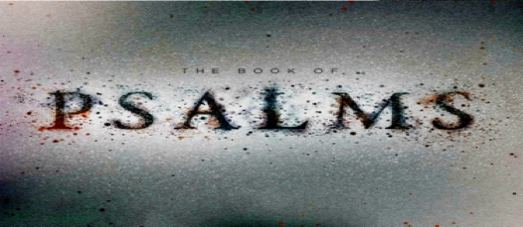
“Chiming In” with Pastor Sandy
Consisting of 150 chapters, Psalms is the largest book in the Bible. It is a collection of poems and songs used in the music of Israel’s worship of God. The book of Psalms is organized into five, smaller books. Last summer, we began an annual series that surveyed Book One (Psalms 1-41). This year, our “Psalms for Summer” series brings us to the second book, Psalms 42-72. Worship with us in person or online at clarksburgcc.org.
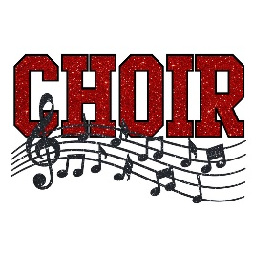
Church News cont.
Church Choirs
All choirs begin Wednesday, August 31! Adult Choir will be at 7:00-8:30 pm in the sanctuary directed by Keith Connor. Youth Choirs will be at 6pm in the Community Hall led by Tiffani Taylor. The Worship Team will continue rehearsing on Wednesdays as scheduled.

New Church Officers
At the annual church meeting on June 12th, the church membership voted in the following officers:
Moderator: Don Clark (expires 2024)
Vice-Moderator: Shari Winkler (expires 2024)
Treasure: Tiffani Taylor
Clerk: Peter Finn

Church Directory-Pictures Needed
Please provide updated contact information and pictures of your family to information@clarksburgcc.org for the new church directory. Pictures should be clear, visible and in jpeg format. Contact Tiffani in the church office if you have questions. The directories will only be available to church families and not shared with anyone else.

Community News
Fourth of July Parade
Clarksburg’s annual Fourth of July parade will take place on Monday, July 4th. All parade participants meet at the firehouse at 11:00 a.m.

FCSR’s Sip of Summer
Join the Friends of Clarksburg Services and Recreation for their Second Annual Sip of Summer at Grand Island Vineyards on Friday, August 12th. Funds raised will go toward the development of the North Delta Aquatic Center. This year’s theme is “Takin' It Back to the 80's!” You won't want to miss this tubular time with dinner by Acoustic Events, a live auction, locally made desserts and dancing the night away to tunes of the 80's. www.clarksburgrecreation.com for tickets.

