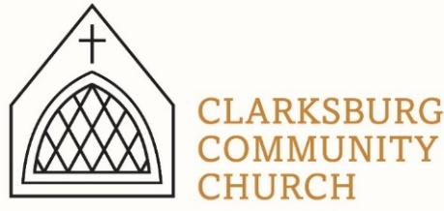
Non-Profit
Bulk Mailing
Clarksburg, CA
95612
Permit #1
Third Class
Chimes
PO Box 36 Clarksburg, CA 95612
52981 Netherlands Ave
May 2023 Chimes

VBS 2023

VBS is June 5-9 from 9:00-11:30 a.m. Registration is open for kids Kinder-6th grade and for helpers 7th grade and up. Look for the link on our website, clarksburgcc.org.
Clarksburg Community Church
Things to Know:
Announcements:
- May 7: Scout Sunday, No Sunday School.
- May 11: Men’s Group Family BBQ at Heringer Estates, 5:00 p.m.
- May 14, 21 & 28: Coffee fellowship from 9:00-9:45.
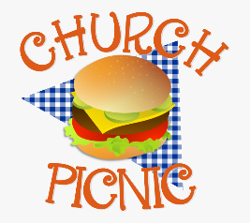
- May 21: DHS Baccalaureate Service, 7:00 p.m.
- June 4: Outdoor worship and church picnic
- June 5-9: Stellar VBS, 9:00 a.m. – 11:30 a.m.
- June 19-24: Middle School and High School Camp

Summer Music:
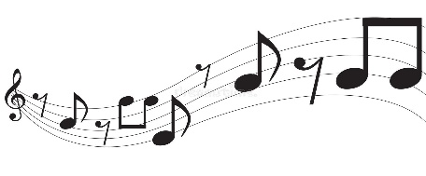
All vocalists and instrumentalists who would like to share your musical talents this summer during the worship service, please sign-up in the Main Entrance or email Tiffani at information@clarksburgcc.org.

Church Contact Information
- Church Office: 916-744-1422; Email: information@clarksburgcc.org
- Pastor Sandy Adams, Jr. – pastorsandy@clarksburgcc.org
- Administrator & Children’s Ministry Director, Tiffani Taylor tiffani.taylor@clarksburgcc.org
- Tiffani’s office hours: Monday, Thursday, and Friday from 9am-1pm.

*Visit our website, clarksburgcc.org, for up-to-date information and to worship with us online. Services can also be found on our YouTube page, “Clarksburg Community Church.”

Construction Update
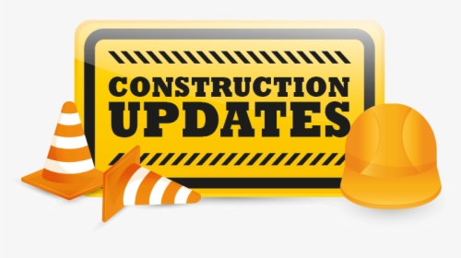
The remodel of the church building’s east wing is in progress with new windows being installed soon! Once completed, the large room will host the DECS pre-K program during the school year and church nursery on Sunday mornings. The two restrooms in the back will be updated and a new restroom will be built attached to and accessed from the large room. Also, the children’s ministry area upstairs has new efficient windows, air conditioning and heat! Thank you to our trustees and house committee for all their hard work in overseeing this project that will benefit our church and community.
Volunteer Needed
The Friendship & Concern Committee has need of someone with an eye for flower arranging to provide floral center pieces for tables at funerals and memorial services at the church. For more information, please contact Kathleen Updegraff at 916-744-1029.

Oasis Youth Group
Spring has been a time of both fun and meaningful activities for Oasis Youth Group. April 8th, we took a group of 18 teens to help feed the homeless dinner at Union Gospel Mission. Then, the egg hunt was on as our teens hid over 500 eggs for the church's annual Easter celebration! We also took 24 people to see "Jesus Revolution" in the movie theater, accompanied by LOTS of popcorn! (Special thanks to our sweet congregational sponsors for covering both the tickets and treats!) Nine students are graduating from youth group this year! Youth group on Sunday, May 21st will be a celebration for them. Then it's on to summer camp at Heavenly Hills June 19-24th!

Church Missions Highlight: Sally Clark
For almost two years, I have been working in Development (fundraising) & Communications for EMI (Engineering Ministries International). EMI is a Christian mission of engineers, architects and other design professionals providing low-cost design services for non-profits and ministries around the world. Most non-profits have a vision for how they can better serve their communities through facilities but need help executing it. This is where EMI meets their needs. Our projects include churches, schools, hospitals, water systems and more. Our
clients range from large global ministries like Samaritan’s Purse to small grass roots local non-profits. I am currently working in our South Africa office which is located in Cape Town and serves the Southern Africa region. In South Africa, with the still raw impact of apartheid, I have seen how God is working through EMI as we partner with ministries and NGOs (Non- Governmental Organizations) working towards reconciliation and restoration. We recently completed a project with the Church of the Holy Spirit (CHS) Life Centre which exemplifies how God is moving in this context. Not only is CHS a church, but also a community center being the hands and feet of Jesus. In their center, CHS provides showers for the homeless, ballet classes for children, meeting rooms for businesses, a coffee bar for training baristas and so much more. A unique aspect of this project is a table which stretches from inside the church to outside as a public representation that all are welcome. CHS had this vision for over 20 years as they continuously gathered to meet in a shed, patiently waiting for God to say “now”. When they connected with EMI a couple years ago, they knew it was time & in January of this year they met for their first service in the newly constructed building!

It has been amazing working for EMI and getting to see God’s hand moving throughout the world towards restoration. I would not be able to do this without the support of Clarksburg Community Church. You are each a critical piece in God’s work, and I am so grateful for you all.

Thank you for your prayers and support! – Sally Clark

To learn more about EMI, please visit their website at emiworld.org, and sign-up for Sally’s newsletter at http://eepurl.com/hFpsA5.

“Chiming In w/ Pastor Sandy”

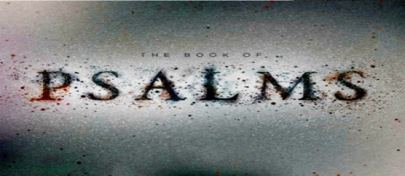

Psalms is the largest book in the Bible consisting of 150 poems and songs that were organized into five, smaller books. Two years ago, we began an annual summer series surveying selected Psalms from the five respective books. Beginning June 4th our “Psalms for Summer” series will sample Book Three, Psalms 73-89. Worship with us in person or online this summer at clarksburgcc.org.

