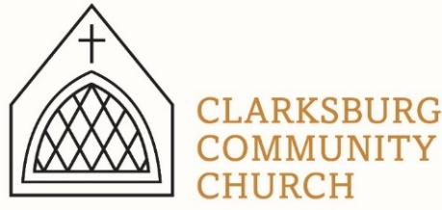
Non-Profit
Bulk Mailing
Clarksburg, CA
95612
Permit #1
Third Class
Chimes
PO Box 36 Clarksburg, CA 95612
52981 Netherlands Road
February 2022

Begins Wednesday, March 2nd
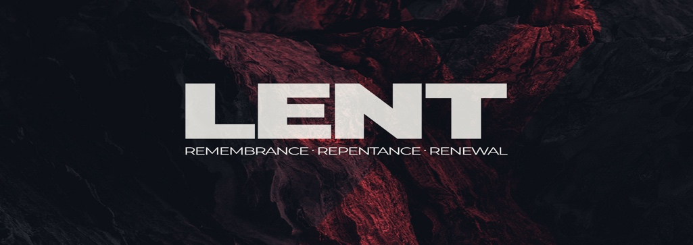
Clarksburg Community Church
Things to Know:

Upcoming Events
- Tuesday, February 22nd: Church Council, 7:00 p.m.
- Saturday, March 12: Men’s Group 7am
- Thursday, April 14: Maundy Thursday Service 6pm
- Sunday, April 17: Easter Sunday

Sunday Schedule
- Sunday School for all ages, 9:00 – 9:45 a.m.
- Worship Service, 10:00 a.m.
- Nursery available during worship service for infants to four-years

Church Contact Information
- Church Office Hours: Monday & Thursday, 9am-1pm or by appointment.
- Office Phone: 916-744-1422
- Office email: information@clarksburgcc.org
- Pastor Sandy Adams, Jr. – pastorsandy@clarksburgcc.org
- Church Administrator & Children’s Ministry Director, Tiffani Taylor – tiffani.taylor@clarksburgcc.org

*For updates and the link to the church calendar see our website at clarksburgcc.org. To watch the service online please visit our website, www.clarksburgcc.org and click “Watch the Service” or go to YouTube channel, Clarksburg Community Church.

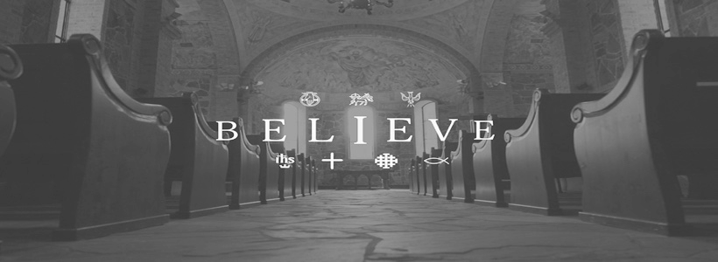

“Chiming In w/ Pastor Sandy”
You may have noticed an emphasis on being committed to what we believe in my recent messages. Hopefully, this had led you to ask: “what are we supposed to believe?” On Sunday, February 13th we began a series that will examines ten, essential beliefs of the Christian faith titled, I Believe. Here is overview of the series:

- February 13th: “The Reality of God – Faith”
- February 20th: “The Revelation of God – The Bible”
- February 27th: “The Relationship of the Godhead – The Trinity”
- March 6th: “The Redeemer of the World – Jesus”
- March 13th: “The Reality of God’s Power – The Holy Spirit”
- March 20th: “The Representative of God’s Kingdom – The Church”
- March 27th: “The Results of Depravity – Sin & Human Nature”
- April 3th: “The Resurrection of the Dead – Last Things”
- April 10th: “The Restoration of God’s Plan – Eternity”
- April 17th: “The Reason to Believe – The Resurrection of Jesus”

•Special Thanks: Gene Naugle and his family would like to extend a big “thank you” to the Clarksburg community for celebrating his 95th birthday with him. It was quite the celebration with over 50 birthday cards (and counting), phone calls from loved ones, and a very special drive by and Covid-friendly outdoor visit with friends from the community. As Gene always says, “Every day is a good day, some are just better than others.” Thank you for making his day extra special. Clarksburg is truly a one-of-a-kind place to call home

•In Memoriam: Bill Isaacson died on Saturday, February 12th at the age of 94. Bill was a member of CCC for several decades having served in the church choir and as a trustee for over 30 years. Bill passed away peacefully at his home with his family by his side. Funeral service plans will be announced when finalized.

Children’s Ministry
•Vacation Bible School: VBS 2022 will be June 5-10 from 9:00-11:30 AM. This year’s theme is “Monumental” and we will learn how big and great our God is! VBS is for children entering Kindergarten through 6th grade. Look for student and volunteer sign-ups soon!
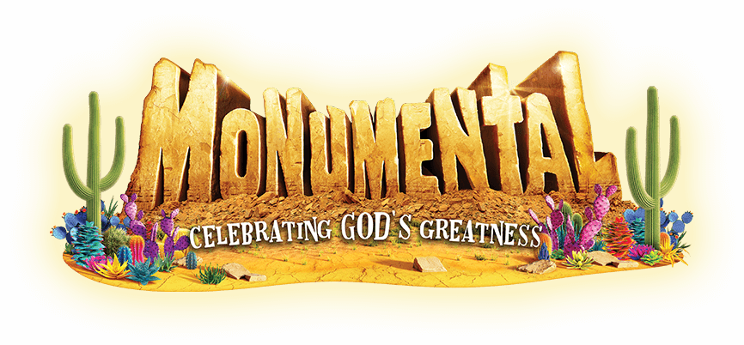

•Nursey: The nursery is open during Sunday morning worship for children 0-4 and enjoy the service. There is a sign-up board in the foyer if you are willing to serve in the nursery.

Oasis Youth Ministry
•Youth Group Updates: Not only is Oasis alive but doing very well! Our interim directors, Raquel Rapp and Becky Morazzini, are doing an outstanding job in leading the ministry and scheduling events, activities and special speakers. Continue to pray for Oasis as the church seeks God’s will for its long-term leadership.

•Summer Camp 2022: We are thrilled to be sending our students back to Heavenly Hills Christian Camp June 19-25. The kids had a blast last year, making friends, singing with the worship band, playing games, swimming, hiking, and learning about their faith! Information will be available soon for our 7-12th graders. Go to heavenlyhillscamp.org/teencamp.html to check out the schedule AND see some pictures of our students from last year!

Church News:
•Church Council: On Tuesday, February 22nd, the Council will consider a proposal from the Trustees allowing Delta Elementary Charter School to lease a portion of the building for Transitional Kindergarten classes for the 2022-23 school year. Comments and questions from the church and community are welcomed. The meeting will begin at 7:00 p.m.

•Directory Update: We are updating our directory and need your help. Please provide any new contact information and pictures of your family to information@clarksburgcc.org. Pictures should clearly show everyone’s face, have good lighting and be in jpeg format. Contact Tiffani in the church office if you have questions.

