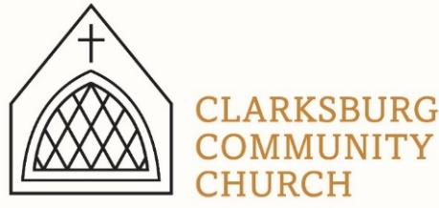
Non-Profit
Bulk Mailing
Clarksburg, CA
95612
Permit #1
Third Class
Chimes
PO Box 36 Clarksburg, CA 95612
52981 Netherlands Road
December 2021

Clarksburg Community Church
Things to know:

Upcoming Events
- Sunday, December 5: Church membership vote on recommendation by the Church Council to end our denominational affiliation with the United Church of Christ.
- Saturday, December 11: Men’s Group 7am
- Sunday, December 12: Youth Choirs singing in morning worship, 10am.
- Sunday, December 19: Christmas concert at 7pm. Contact Kathy Hunn if you would like to participate in the concert, 916-417-7441.
- Friday, December 24: Christmas Eve candlelight service 6:00pm
No Sunday School on December 26 and January 2. Sunday Worship will still be at 10 am.
Christmas Concert: December 19, at 7pm. Join us for a beautiful time of music and worship to celebrate the Christmas season. This event is open to everyone.
Contacting Clarksburg Community Church
The church office is open Monday and Thursday from 9am-1pm or by appointment.
Office Phone: 916-744-1422 or email information@clarksburgcc.org
Pastor Sandy Adams: pastorsandy@clarksburgcc.org
Office or children’s ministry, Tiffani Taylor: tiffani.taylor@clarksburgcc.org

*For updates and the link to the church calendar see our website at clarksburgcc.org.
Remembering those we lost this year:
Mike Parr
Paul Grose
Mary Ann Pylman
Shirley McDonald
Hazel Kirtlan
Mary Clark
Becky Broadbent

Youth Group Christmas Party
The youth group will be having a Christmas party on Sunday, December 12th from 4pm-6pm. This will be a fun time of fellowship, cookies, hot chocolate, a white elephant gift exchange, Christmas message and some swing dancing taught by Chase Bender. All high school age students are welcome, and bring a friend!

Children’s Ministry
We are enjoying our new large room upstairs! This great new kids space allows for multi-age classes and more room for wiggles. There are plans to add new furniture and make the large room into the elementary room and the other upstairs room our new preschool room. We are excited to grow our program as we continue to welcome new children.
Nursey News: The nursery has been opened back up during Sunday morning worship to allow parents to drop off children 0-3 and enjoy the service. There is a sign-up board in the foyer if you are willing to take a turn serving in the nursery.
*If you have any questions about children’s programs contact Tiffani Taylor at tiffani.taylor@clarksburgcc.org.

End of Year Gifts
If you planning on giving an end of year gift to Clarksburg Community Church, please be sure those are received by the church before December 31. We appreciate those end of year gifts, and strive to be good stewards of the money entrusted to the church.
“Each of you should give what you have decided in your heart to give, not reluctantly or under compulsion, for God loves a cheerful giver.” -2 Corinthians 9:7

Information Update:
Clarksburg Community Church has changed information systems to ChurchTrac. We are trying to get all information updated and switched over. If you would like your information to be updated or to be removed from the list email information@clarksburgcc.org.

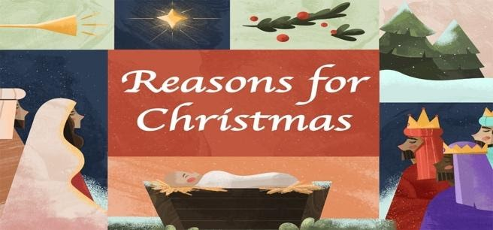
“Chiming In w/ Pastor Sandy”

We have all seen the signs, bumper stickers and sweatshirts during the holiday season declaring “Jesus is the Reason for the Season.” While that is certainly accurate, have you ever wondered what are the reasons the Son of God became human? Our Christmas series this year will look at three reasons Jesus gave for coming to earth, all recorded in the Gospel of John. Understanding these reasons will help us appreciate more fully why “Jesus is the Reason for the Season.” We hope you will worship with us in person at 10:00 a.m. or watch us online at www.clarksburgcc.org if you are unable to attend.

While 2021 was somewhat more “normal” than last year, there are still adjustments and inconveniences being experienced during this age of the COVID-19 pandemic. If you are able to travel for the holidays or planning to stay home, I hope this season is a wonderful time for you and your families.

God has been good to Clarksburg Community Church, and I am looking forward to seeing what is in store for us in 2022. May you have a blessed Christmas season and a Happy New Year!

