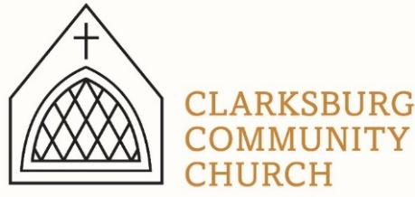
Non-Profit
Bulk Mailing
Clarksburg, CA
95612
Permit #1
Third Class
Chimes
PO Box 36 Clarksburg, CA 95612
52981 Netherlands Ave
August 2023 Chimes

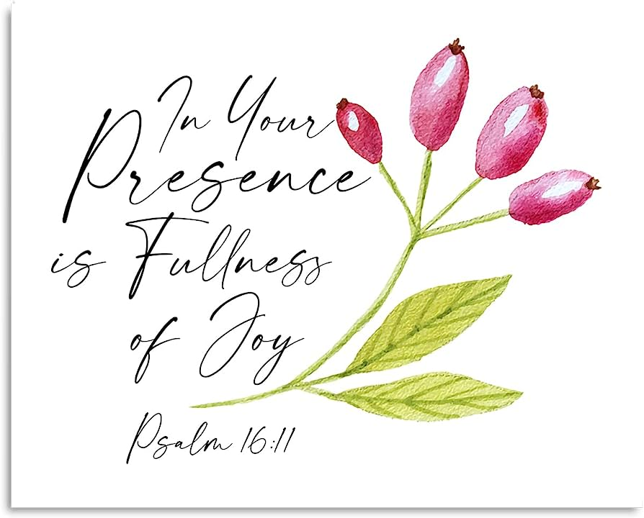

Clarksburg Community Church
Things to Know:
Announcements:
- Wednesday, September 6 from 7:00-8:30 p.m. choir practice resume.
- Wednesday, September 6 from 6:00-6:45 p.m. youth choir practice begins. Open to children kindergarten through 6th grade.
- Sunday, September 24 from 3:00 – 4:00 p.m. - Baptism Class
- Saturday, October 14 at 7:00 a.m. - Men’s Group
- Sunday, November 12 - Clarksburg Country Run. Service moved to 4:00 p.m. with Soup, Sides and Salads Fellowship to follow.

- Sunday School Begins Sunday, September 10 at 9:00 a.m.
  - Kathleen Updegraff and Debra Townsend are leading a class for all women. They will be reading The Awe of God by John Beviere.
  - Children from preschool through 6th grade will be upstairs with Ms. Taylor learning about our God through Old Testament stories.
  - The Koinonia Café each Sunday from 8:45 a.m. – 9:45 a.m. Refreshments will be served.

Church Contact Information
- Church Office: 916-744-1422; Email: information@clarksburgcc.org
- Pastor Sandy Adams, Jr. – pastorsandy@clarksburgcc.org
- Administrator & Children’s Ministry Director, Tiffani Taylor tiffani.taylor@clarksburgcc.org; Office hours: Monday, Thursday, and Friday from 9am-1pm.
- Directory of Youth Ministry, Aundriea Montzingo youth@clarksburgcc.org

*Visit our website, clarksburgcc.org, for up-to-date information and to worship with us online. Services can also be found on our YouTube page, “Clarksburg Community Church.”

“Chiming In w/ Pastor Sandy”
One of my favorite New Testament words is koinonia, a Greek word that has been translated into English as “fellowship.” In the time of the New Testament, koinonia literally meant “communion” or to “share in common.” The first Christians shared in common their faith in Jesus Christ as Lord and the suffering that resulted from it.

While we may not necessarily be suffering for our faith, we certainly do suffer in faith. True, biblical fellowship is needed as much today as it was in the first-century church 2,000 years ago. Therefore, it is important for the church to foster a spirit of koinonia and provide opportunities for genuine fellowship.

Beginning Sunday, September 10th, the Koinonia Café will take place from 8:45 a.m. – 9:45 a.m. This will be an opportunity to gather in the Community Hall for conversation, build relationships and strengthen our faith. Refreshments will be provided and is open to all adults.

Other upcoming opportunities for fellowship are the Men’s Group, which meets on the second Saturday of the month from October – April at 7:00 a.m., and the new Women’s Ministry whose first event will be a dessert fellowship on Monday, August 21st at 7:00 p.m.

While fellowship is more than a social event involving food, these events are great ways to encourage koinonia in our local body and share our faith.

Oasis Youth Group
An exciting change is coming to Oasis Youth Group! Aundriea Montzingo has been hired as the new Director of Youth Ministries for CCC. She is a long-time church member and coaches volleyball at Delta High School. Aundriea has a heart for our youth and is excited to begin working with our students. She will be building a team of adults to serve with her in supporting and caring for our students.

A huge THANK YOU to Raquel Rapp and Becky Morazzini who have done a great job serving as interim youth directors the past two years.

On August 27th, there will be a Back-to-School Pool Party at 4:00 p.m. hosted by the Morazzini family. Youth Group will resume weekly meetings beginning Sunday, September 10th from 4:00 p.m. – 5:30 p.m. All students in 7th – 12th grades are welcome to attend youth group and all special events.

DECS TK:
The church will continue leasing classroom space to Delta Elementary Charter School for two Transitional Kindergarten class this school year. Progress is being made on the East Wing classroom with the hopes of it being ready for use by early fall.

Birth Announcement
Congratulations to Russel and Rachel Pope on the birth of their son, Remington Carter Pope. He was born July 27th, weighing in at 7lbs 9 oz. Mom and baby are doing well. Baby Remington is welcomed home by big sister Reya.

In Memoriam
Erma Wilson passed away on July 15th at the age of 95. A celebration of life service was held in her garden on August 7th. We rejoice with the Wilson family for a life well lived.

Member Update
Gene Naugle has moved to the San Diego area to be near family. His new address is 2103 El Amigo Rd, Del Mar, CA 92014. He would enjoy a card or note from any of his Clarksburg church friends.

Women’s Ministry Event
Women of all ages, you are invited to an evening of Dessert and Fellowship!
Monday, August 21 at 7:00 p.m.
Bring your favorite dessert with a recipe card. We will get to know one another while sharing desserts and swapping recipes. This will be a fun time for our ladies to take a break, laugh together and support one another.

Volunteer Needed
The Friendship & Concern Committee has need of someone with an eye for flower arranging to provide floral center pieces for tables at funerals and memorial services at the church. For more information, please contact Kathleen Updegraff at 916-744-1029.

