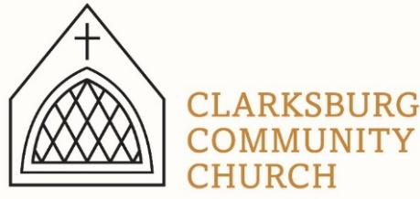
Non-Profit
Bulk Mailing
Clarksburg, CA
95612
Permit #1
Third Class
Chimes
PO Box 36 Clarksburg, CA 95612
52981 Netherlands Ave
August 2022

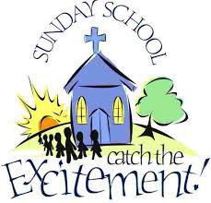
Sunday School for ALL ages begins September 11 at 9:00 a.m. Everyone is invited!

Clarksburg Community Church
Things to Know:
Announcements:
- Sunday School begins September 11th at 9:00 a.m. followed by worship at 10:00 a.m.
- The final Bylaws Q&A Forums are scheduled for September 8th from 10:30-11:30 a.m. and September 22nd from 6:30-8:00 p.m.
- Scan the QR below to register for Wines of Clarksburg and Art Auction

Sunday School begins 9am on Sept. 11. Classes offered this fall:
- Infants-3 year’s old will be in the temporary TK room.
- Children 4-12 will be upstairs exploring Old Testament heroes with Mrs. Taylor.
- Middle and High Schoolers will be in the HS room with Mrs. Rapp and Mrs. Adams.
- The Women’s class, led by Kathleen Updegraff will study Colossians & Philemon.
- “A Closer Look” is a sermon-based study led by Pastor Sandy that will go more in depth into the Sunday morning sermon series, open to everyone.
Small Groups:
- The Monday women’s Bible study begins September 12th from 9:00-11:00 a.m.
- Men’s Group resumes Saturday, October 8th at 7:00 a.m.
Church Contact Information
- Church Office: 916-744-1422; Email: information@clarksburgcc.org
- Pastor Sandy Adams, Jr. – pastorsandy@clarksburgcc.org
- Administrator & Children’s Ministry Director, Tiffani Taylor –tiffani.taylor@clarksburgcc.org

*Visit our website, clarksburgcc.org, for up-to-date information and to worship with us online. Services can also be found on our YouTube page, “Clarksburg Community Church.”
Youth Group
“Camp Memories from a Counselor” by Raquel Rapp, Co-Interim Youth Director
Why do you hear and feel God more on a mountain? This past June, I had the chance to attend camp with 14 of our high school youth group kids at Heavenly Hills Camp in Twain Hart. Little did I know God not only had plans for the kids, but also for me as well! God brought together the perfect students and leaders with so many interesting backgrounds to this camp from Chico to Los Angeles. This year’s theme was “Transformed” and I believe that happened with many of the campers.

We enjoyed so many team building, competitive and encouraging experiences, such as hiking, horseback riding, swimming, and learning who God says we are in the Bible. Pastor Sandy and Sam joined us for a few days. It was fun to share the experience with them. Ryan Bonilla was hired as a summer camp worker but took the week off to be a camper with us. Our Delta students performed a five-minute skit of the “Lion King with some creative and hilarious twists! We got to worship with a live band every night and we’ll never forget the campfire testimonies given by almost everyone there.

Since I didn’t grow up in the church, this was my first Christian camp experience that I’d always felt I missed out on. Our God is so good, ALL the time.

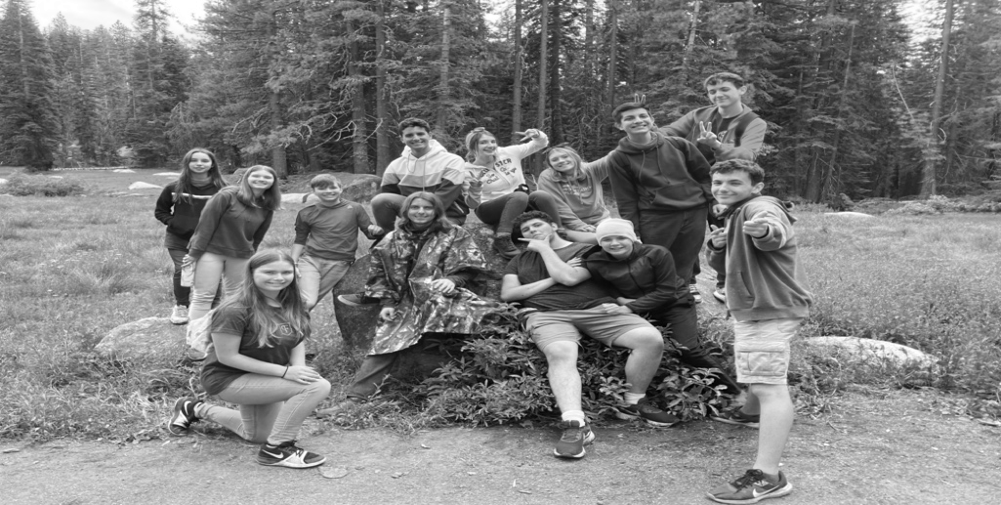

Upcoming Youth Events:
Sunday August 28th: Youth Group, 4:00-5:30
Saturday, September 3rd: Teen Service at Bayside Church, Granite Bay
Sunday September 11th: Swim Party at the Clark’s, 4:00-5:30
Friday, September 16th: Jordan Feliz Concert @ Fair Oaks Church
Sunday September 25th: Youth Group, 4:00-5:30
Missions
Over the last two years, the church has been supporting Sally Clark in her work with Engineering Ministries International (EMI). Sally will be sharing about here ministry in our worship service on Sunday, September 25th. Come and hear what God is doing in this wonderful ministry and what Sally will be doing next!

Choir Rehearsals:
Directors Keith Connor and Tiffani Taylor invite everyone to the Chancel and Children’s choirs. Rehearsals for our fall season begin Wednesday, August 31 at 6:00 p.m. for the children and 7:00 p.m. for the adults.

Construction Update:
The DECS TK (transitional kindergarten) program began on August 10th. Fifteen, four-year olds are temporarily using the Terrace Room for their classroom and will move to the east wing of the church when construction is finished later in the year.

Construction to the east wing of the building will open the Blue Room and nursery into one large classroom. Also included will be renovations of the two back restrooms, construction of an additional smaller restroom, new HVAC system for the back half of the church. The Terrace Room and upstairs classes will also be getting new, energy efficient windows.

Groundwork has already begun on a new and improved playground. Improvements to the playground were necessary because of our partnership with Delta Elementary Charter School and their TK program.

Thank you for your patience and cooperation during the renovation phase for this project. We are excited for the opportunity to partner with DECS and serve our community!

New Sermon Series Begins: September 11th